Lecture 9 – Potential Flows

When flow is both frictionless and irrotational $$\left(∇×v=0\right),$$ momentum eq, I.e. eq 11 reduces to Euler’s eq.

$$δ \frac{dv}{dt}=δg−∇p$$

Euler’s equation is much simpler to solve and it can be very useful for low aerodynamic (as least on a 1st estimate), low vel gas flow, or low vel and low vel gradient conditions for liquid flow, eg. Flow in domestic drainage lines

If flow is irrational, a scaler function, $$φ$$, can be defined as:

$$φ$$ Which is called vel potential

From a vector analysis theorem: $$∇×v ≡ 0 → v = ∇φ$$

$$u=\frac{dφ}{dx}, v=\frac{dφ}{dy}, w=\frac{dφ}{dz}$$

What is $$φ$$ good for?

* It reduces the prob of solving for 3 variables, u, v, w, into a dingle variable, $$φ$$, in the x, y, z domain

Lines of constant $$φ$$ are called “potential lines of flow” and they are normal to streamlines $$\left(ψ\right)$$

$$u=\frac{dψ}{dy}=\frac{dφ}{dx}$$ and $$v=\frac{dψ}{dy}=\frac{dφ}{dx}$$

Unlike $$ψ$$, $$φ$$ can be used in 3D as well

**Question:** How to find the flow pattern around the tornado?

**Answer:** Use of elemental flows, such as: uniform flow, sink/source or pure vortex, etc.

1. Uniform Flow

A uniform flow in only x-direction (I.e. 1D)

$$v=iu$$

$$u=\frac{dφ}{dx}→ φ=ux$$ (Did not write the const of integration as recall $$φ$$ is a const)

At const, x, line const $$φ$$ lines

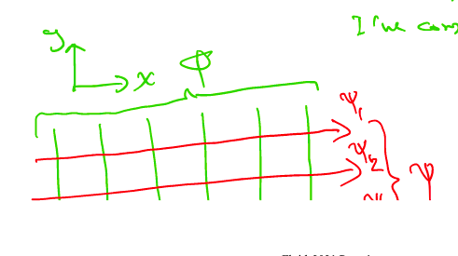

$$u=\frac{dψ}{dy}→ ψ=uy$$ (const y gives $$ψ$$ lines)

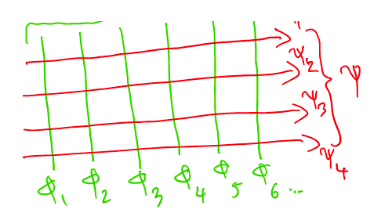

1. Sink/Source Flow

Suppose z-axis was a thin pipe issuing/sucking flow along its length, them from x-y plane, we have:

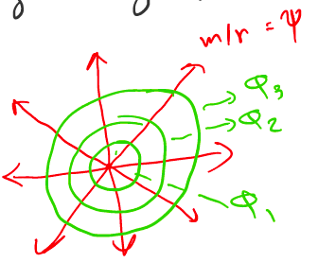

Using pilar coordinates

$$v_{r} = \frac{Q}{2πrb}=\frac{m}{r}$$ (“m” is strength)

(“b” is the virtual thicken in z-dir)

$$\frac{dφ}{dr}=\frac{1}{r}\frac{dψ}{dθ} = v_{r}=\frac{m}{r}$$

After integration $$ψ=mθ$$ and $$φ=m\ln{r}$$

Const $$θ$$ are radical lines

If $$m>0$$--> **source**

If $$m<0$$--> **sink**

1. Line Irrotational Vortex

A pure 2D line vortex is a circulating steady motion

$$v_{θ}=f\left(r\right)$$ only and $$v_{r}=0$$

If flow is irrotational $$∇×v=0 → v_{θ}=\frac{k}{r}$$ (“k” is a const)

$$v_{θ}=\frac{k}{r}=\frac{1}{r}\frac{dφ}{dθ}=−\frac{dψ}{dr}$$

Integrate: $$ψ=−klmr$$ and $$φ=kθ$$

“r”: Const r lines and stream lines

“ $$θ$$“: const $$θ$$ lines, I.e. potential lines

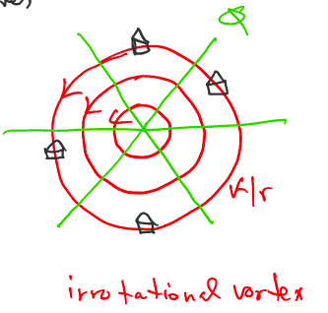

**Note:**

* The above equations for $$ψ$$ and $$φ$$ are all from linear PDEs
* Then the sum of their solution is “a solution” as well $$→$$ concept for super position!

How to make a sink tornado as shown? 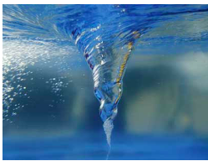

Think of rotation of flow --> **vortex**

Think of drainage of flow --> **sink**

$$ψ=mθ−\ln{r}$$

$$φ=m\ln{r}+kθ$$**see figure:**

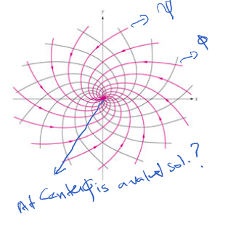

When $$r=0→v ≡ ∞‼$$

But in reality, there is a viscosity (however small) and near center the vel gradient is extremely large, so this combination means that the assumption of frictionless flow will breakdown and solution is NOT valid near the center and at the center $$r ≅ 0$$

Example:

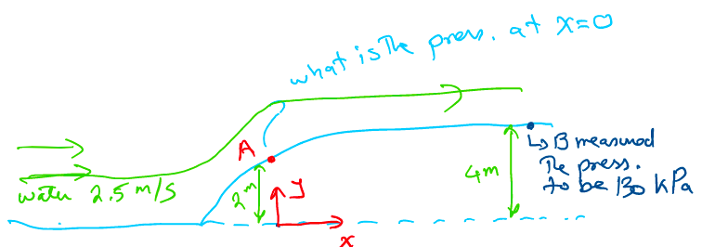

If we consider a source at x=0 and a uniform flow: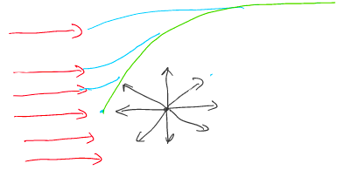

Aside: How to “shape”

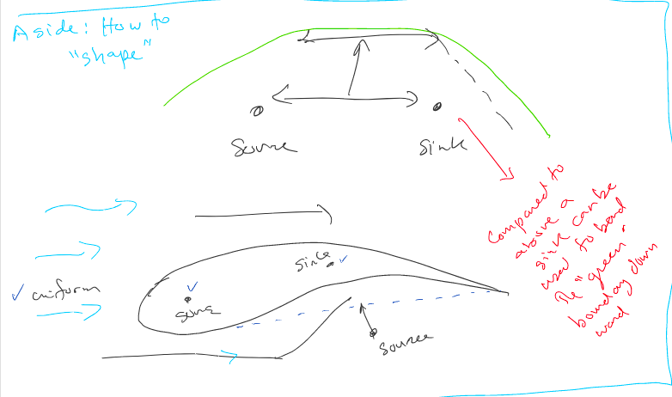

Infact combination of a source at x=0 and a uniform flow will provide he Rankine body as follows:

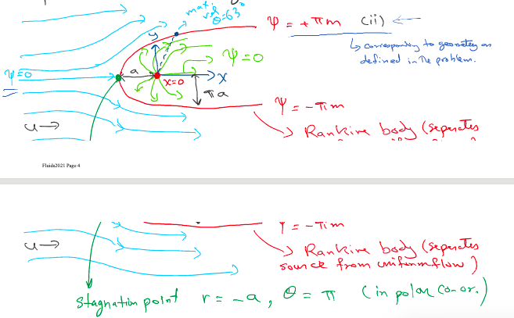

$$ψ=ur sinθ+mθ$$ (I)

* “ $$r sinθ$$“ --> polar coordinate
* $$ur sinθ$$--> uniform flow
* $$mθ$$--> source

Note:

The steam line $$ψ=0$$ crosses $$ψ=+πm$$ (a no no for streamlines!!)

But now it is allowed since they cross at stagnation point when vel is zero

Combining eg (I) and (ii), and considering the Figure above (the top part of it, to represent the bump for our problem):

$$r=\frac{m\left(π−θ\right)}{usinθ}$$

$$a=\frac{4m}{π}$$

To find cartesian vel components

$$u_{x}=\frac{dψ}{dy}=u+\frac{m}{r}cosθ$$ (iii) --> both of these equations

$$v=\frac{dψ}{dx}=\frac{m}{r}sinθ$$

At stagnation point $$v=u_{x}=0,$$ from eq (iii), one finds $$θ=π$$ or 180º and $$r=\frac{m}{u}$$ or $$a=\frac{m}{u}$$ from above figure

Vel everywhere can be founds as: $$v^{2}=u_{x}^{2}+v^{2}$$--> magnitude of velocity

$$v^{2}=u^{2}\left(1+\frac{a^{2}}{r^{2}}+\frac{2a}{r}cosθ\right)$$ (iv)

$$u_{A}=−−−−−−−−−−− = 2.96$$ m/s

Note:

$$ψ_{πm}−ψ_{0}=Q$$

$$ψ_{π}−0=\left(1\right)πa u → a=\frac{m}{u}$$

* $$\left(1\right)πa u$$--> area for unit length out of page

Bernoulli equation along the streamline $$\left(ψ=πm\right)$$ can be applied:

$$\frac{P_{A}}{γ}+\frac{V_{A}^{2}}{2g}+Z_{A}≈\frac{P_{B}}{γ}+\frac{V_{B}}{2g}+Z_{B}$$

We assume Vb = 2.5, as it is down in horizontal section of flow similar to the uniform flow (slip condition holds as flow is considered frictionless)

$$P_{A}=109, 200 P_{a}$$

Observation:

Since we used different approach, we can able other questions such as where is max vel on the bump, since we have access to details of flow field in the different approach

Max vel point on the body $$\left(ψ=πm\right)$$, after differentiation can be found that is on $$θ=63º →$$ this point is the min pren. point

* The min pren point lecoation is the most important as flow reversed downstream of the location many happen that can give rise to formation of flow separation and appearance of eddies (see chap 7 later)

NOTE: Stream function and vel potential function method of analyzing fluid flow through combination of elemental flows is like rapid prototyping seen in manufacturing. One gets a quick but approximate feel/knowledge for flow field to make descriptions